**Introduction - Week 1**

**Company:**

*Name:* LAMF Industries

*Logo:*

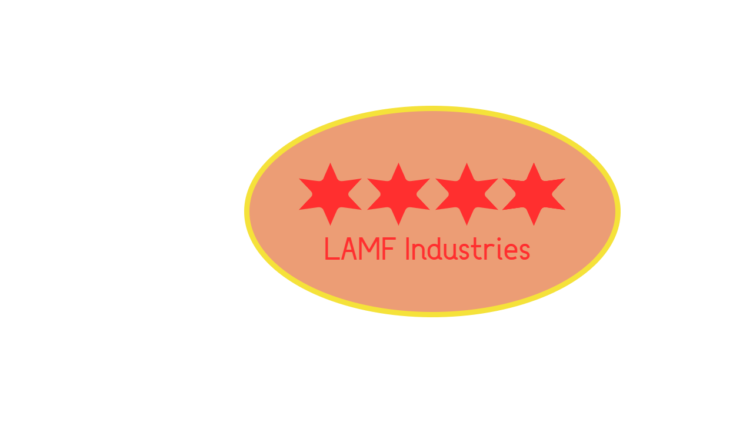

*Mission:* The main mission of our company is work with other companies to allow the growth and development of their business, to help increase profits as well as increase the number of good employees which fit the companies needs and requirements. In return, our company earns a small percentage of the profits in return of the cooperation, both allowing our company to grow as well as support other companies to help gain their trust and support in the future. Our employees at our company have many different skills which could all help improve and grow other businesses such as the job application industry. We believe it is very important to make sure that advertising and modernisation is a key focus, while also ensuring that the number of customer complaints, which could potentially affect their company’s reputation and reliability can be effectively reduced.

*Motto:* Think, Feel and Hear

**Introduction:**

The purpose of the Online Recruitment System is to help iSeek expand their business and receive vacancies by developing a new system where the employer would be able to directly advertise their vacancies through a standard online Job Offer form on their employer’s portal. The aim of the project is to allow the employer to create a personal account where they can modify their advertisement through their portal. On this personal account they can input information such as job position, description, the required qualifications along with the information about the job opportunity. In this system, the employer would be able to view the responses for their advertisements.

Their initial ideas are to make sure that the applicant can register on the new iSeek system before being able to apply for the job role, so that they can fill out an online form and provide information such as their work experience, their education, and other key aspects. The applicant should also be able to check up and update their records at any time. From the employer’s side, the online system should be capable of finding matches in their vacancy ads by comparing the appropriate applicant details before being able to proceed and give the applicant an interview opportunity. They also want the system that can transfer payments through their system of service by the employer if the applicant is hired for the job.

This can be a real business need for iSeek to develop this new Online Recruitment System as it would be a more effective way of managing their job applications rather than spending money, time and resources on jobs that used to manage their incoming emails and calls, regarding to the job applications. Since they used to store all the information on the job applications in a book and occasionally on spreadsheets, a new Online Recruitment System would help in managing time and resources that could be spent elsewhere. Meanwhile, the system would store and process the applications by applicants to find a similar match to their candidates. This would allow them to identify the best candidates for job automatically and then proceeding to notify the employer and applicant for an interview. This way they would be able to provide a good expansion to their services and reduce the number of staff problems in iSeek and the number of customer complaints, which could potentially affect their company’s reputation and reliability.

The use of instant messaging systems in our company, has allowed us to effectively communicate with one another on the project through the internet so that we can all work productively together. Instant messaging systems has helped increase our productivity by allowing everyone to send and receive messages, sharing files and documents, therefore allowing us to work to be able to continuously provide regular feedback to ensure that our projects are the best that they can be. The use of instant messaging systems has therefore allowed us to cut costs in our budget by reducing the number of in-person meetings required. These messaging systems allows us to effectively share and discuss our ideas, through regular communication and as a result, meeting the needs and requirements of our project. By cutting on our resources and costs, this has made our project much more efficient, and money could be spent elsewhere. For example, money could be used on testing and improving, rather than on physical meetings because they could easily be replaced by using the instant messaging systems with the use of the internet.

*Project Manager* – the role of the project manager in developing the system proposal is to plan activities and manage resources in the project to ensure that everyone can meet the project deadlines. This would minimise the risk of the project failing as the project manager would effectively plan and manage project resources. Their role would be to be organise and manage the project development team and ensure clear communication is present and therefore a better product can be developed which meets the needs and requirements of iSeek. The project manager helps in meeting deadlines through regular meetings, where all the team can share and collaborate their ideas so that the next version of the product can be improved upon. The project manager’s role in the team is to ensure customer satisfaction, monitoring progress, managing reports, analysing, and managing project risk so that they can be evaluated before the project begins. This would therefore allow our development team to effectively avoid and mitigate the risks of the project, while also minimising their impacts.

*System Analyst* - The role of a system analyst is key within any project that is undertaken. They are responsible for firstly analysing what the current situation of the business and where it is at. They are then responsible for identifying areas which are working well and areas which require improvement. Overall, they are then responsible for assisting in the creation of designing the required aspects such as software for improving the business, which in the case of iSeek and our company LAMF to create an online recruitment system. This role is also responsible for maintaining close links and working closely with other colleagues and clients. This could include more technical experts such as the programmers, the client itself who the software will most likely be for, and any other partners that are brought onto the project.

*Software Developer* – This role would be suitable for someone who can create the software of the company and make it perform very well on all types of operating systems, that should be easy to use for the customers and staff so all the data must be secured and organised. The layout design should also represent what iSeek company is offering for the customers.

*UI Designer* – This role is key in the development of any visual interface which a user might see in a project. UI or User Interface Designers are responsible for the overall visual aspects of the project including but not limited to the projects visual design, the projects overall layout and its general interactivity with the end user as well as its maintainers. This could include certain items such as the creating of a website design or layout. This could also include more complex areas such as creating a GUI for the software being used. The UI designer is key in the layout and implementation of projects.

Our key considerations for the system are to make sure that the product is fully functional, operational and meets all iSeek’s requirements. The Job Recruitment System project should have different functions and admin rights based on the user and securely storing logins, passwords, financial information in their system to make iSeek’s business function more effectively and efficiently in managing job applications and finding right matches automatically. We need to make sure everyone in the team has their roles and responsibilities in the project and that the product contains:

1. Good quality of data that allows them to make a wide variety of choices.
2. A great system design that will attract the job applicants/customers.
3. Making sure that the data stored inside the system is secured by the company.
4. Filters the data in the applications to give overview of the results needed for the applicant.
5. Scalability of the system so that will implement the features and would be fully operational and functional.
6. The system should be capable of performing and working on multiple operating systems and devices.

**Methodology:**

The Phased Development Methodology is suitable for developing iSeek’s new Job Recruitment system because it would use computer tools along with joint application sessions to get some portion of the system developed quickly and in the user’s hands. By continuously having joint application sessions in the phased development methodology, it would allow our company to critically evaluate each version of the Job Recruitment System, so that we could all help provide solutions. This would allow us to provide regular feedback so that each version of the system can be developed on sequentially. Each version of the series would be improved upon and due to the short 4-month development time constraints, this would allow the users to get a system out quickly where the job applicant would be able to create an account and provide their employment details so that the employer could potentially give them an interview. Since users get a system quickly, the application process would not be delayed and therefore iSeek, would be able to continue receiving job applications over the 4-month development period. This would therefore provide our company with more regular feedback from iSeek, on how the system is performing based on the stakeholder’s experience so that any additional needs can be implemented in later versions after being discussed during each joint application meeting.

We believe that the Phased Development Methodology is best suited for iSeek’s Job Recruitment System which can be seen in the “The Software Development Life Cycle” book by Everett, Gerald D; McLeod, Raymond; Everett, Gerald D; McLeod, Raymond Hoboken. In chapter 2, page 33-34 of the book mentions that ‘each subsystem represents the objective of a separate development phase’. From this we can deduce that each stage of the development phase is treated as a separate version of the product. This would therefore allow us to develop and continue to improve upon each version of the system, ensuring that we can meet the requirements after each meeting and cycle of this development methodology. It is also mentioned that ‘once work on individual phases is completed, the subsystems are integrated to form a whole solution’, which shows us that the phased development methodology was the best option for developing the project because each version of the system are developed in a ‘iterative manner’. The image of the phased development methodology diagram helps visualise the repetitive structure of the development life cycle where the analysis, design, preliminary construction stages each phase is repeated to create version 1. The same cycle is repeated with the same version to improve it. This would be beneficial in development of the Job Application System because this would ensure that all the problems and issues can be quickly solved before the stakeholders get the final version of the system. As a result, this would reduce the margin of failure and the end user will be guaranteed to get a working version of the system that would be easy to use and the employer, admin and job seeker would be able to use of the most important features. Overall, the phased development lifecycle would help increase iSeek’s daily business functionality and productivity because it would ensure that the end-user gets a working product which they can all interact with. The book also mentions that the benefit of using this methodology is that the users can get a system to use quickly, which will help us in the development because of the short 4-month development timeframe. The development is heavily focussed on regular feedback, testing and improvement upon the previous version, meaning that additional needs will be later identified from testing so that the project can be quickly patched, and users will be able to use a fully functional system. Although this methodology requires time to develop a fully functional system, the regular feedback in our team allows us to quickly progress and ensure that all the key requirements of iSeek are met and the Job Recruitment System is fully functional and operational.

**Project Planning – Week 2**

**Feasibility and Risk Assessment:**

The new Job Recruitment System is technically feasible because iSeek need it for their business, to recruit new employees while also being cost and time efficient. Our company in collaboration with iSeek can develop a high-level system that will be able to manage job applications online. We can build the system due to the large budget of £60,000, that would be used on implementing all iSeek’s system requirements that will all work and allow employers to employ applicants that are best suited for the job without the need to recruit staff to manage paperwork and manage incoming calls. Since this allows the iSeek business to be more productive, while also minimising the risk of their business reputation and productivity after their failed business expansion. By building this new Job Recruitment System, there is less risk on iSeek because we are ensuring that when we develop the system, we will discuss and have regular meetings after developing and testing each version in the phased development methodology. This way, the risk will be minimised of the system failing. Since there is many of these types of systems already online, there is a much greater familiarity of the technology used in the system and therefore makes the project more technically feasible because the risk can be reduced. The analysts are familiar in this portion of the business, allowing them to use their expertise and experience to help work on this large game-breaking project for iSeek’s business. It will evolve the way in which they operate and manage their employees' payments, pay administrative fees while also providing many other functionalities. Since there has been similar projects already developed in the past, we need to make sure that our project functions even better and can be further improved by ensuring compatibility across many different devices.

We believe that the project organisationally feasible for iSeek because developing a game-breaking system that will make management and business productivity a lot better. We believe that the users such as job seekers, employers and administrators will accept the system because it would allow them to manage job applications, manage payments and pay administrative fees a lot easier, compared to what they did in the past. Managing paperwork and paying staff to manage calls is not cost, time and resource efficient for their business, mainly after their business had unsuccessfully expanded. The project is strategically aligned with the business because it allows job seekers and employers to log in and view their online forms and applications before finding a right match and proceeding to an interview. Through this online system, their business can increase productivity and not waste time and resources in finding a right match for their job when this can be done automatically by the system by finding matching keywords in their job application. The project is strategically aligned with the business because it would allow them to be more productive and gives them a flexible system which they can expand in the future if they need more features and a greater functionality. The key stakeholders for this project would be the administrators, the employers, employees and the job seekers as they would be the main people using the system. This would be beneficial as they would be able to use modernisation in their business and reduce the number of employees, they need to do their paperwork and spreadsheets, when this could all be done a lot easier through their system database. All that is needed is for the system to have a log in for different users and give them different access rights and users should be happy with a system that is easy to use, has many features and is simple to understand.

The new Job Recruitment System, which we are developing for iSeek is feasible because the owner has allocated a large budget of £60,000 to fully complete the project over the 4-month period. We should be able to develop the job recruitment system up to iSeek’s standards, by ensuring that they meet their needs and requirements. The large budget allocated for the project, would make the project feasible to develop a new job recruitment system that can allow job seekers to login and search for vacancies within the company and allow employers and administrators to login, manage vacancies and interview invitations, manage administrative fees and other payments. The system provides so many more benefits for iSeek compared to the cost because the implementation of the features of the system would allow them to modernise their application system and therefore save time and resources on managing paperwork, documentation and allocating staff which manage the job applications through emails and calls. This would allow iSeek to spend their resources elsewhere on their business rather than wasting time and resources to manage job applications. The system would be able to automatically match potential candidates for the job before giving them an interview. Since their failed expansion of their business massively impacted their productivity because the new expansion had caused the staff of iSeek to face many problems. The new expansion of the business has also led to many customer complaints, therefore massively impacting their reputation and decreasing their reliability. This could potentially reduce the number of applications for iSeek’s business, which is why the development of the new job recruitment system would be a lot more beneficial in making the job application process a lot more efficient and the system’s benefits would outweigh the cost of the project. The project would be able to recruit suitable candidates for the job which would be the perfect fit for the business.

**Risk Assessment Table:**

|  |  |  |  |
| --- | --- | --- | --- |
| **Technical Risk** | **Likelihood of Risk (1-10)** | **Potential Impact on the Project** | **Ways to address this issue** |
| Integration of new system into old system | 6 | This is the highest risk in the creation of the project for technical aspects. As the company has been using a different process to the one, we are providing them, there is the potential for severe disruption to business if the integration is not handled appropriately. | Keyways to address this issue include making sure all staff are trained and are aware of how to operate the new system effectively and that there is key infrastructure in place to deal with any issues that may arise. Another area is to make sure that staff are aware of the process of transferring data from the old system to the new system appropriately. |
| Storing Personal Information in Online Database | 2 | There is a small risk in the storing of personal information online if the information is handled incorrectly or proper security procedures are not put in place to safeguard it. | One way to address this issue is to make sure that all staff are trained on proper data handling within the new online system, which can take place during its integration. Another way is to make sure appropriate security measures are put in place to stop unwanted access to the database. |
| System not finding job matches | 5 | This has a moderate risk to the company as there may not be the right number of jobs or the appropriate job that the person is seeking using the system which in turn could stop people from using the company. | Ways to mitigate this is to make sure that there are always jobs shown to the user on the system and that there are clear instructions for users so they can always find the appropriate job match. |
| Not being notified of their match and interview | 4 | This has a low – moderate risk to the company as there could be an error in notifying the user that the job has been matched and that interviews or more questions have been submitted to them. | Ways to mitigate this include the notifying of the user via different methods of communication, for example through the system itself, via text or email are appropriate options and will cover most avenues to alert them that a job has been found. |
| Not being able to register or log in | 7 | If users are not able to register or login, then there is severe risk to the company as this will stop users from being able to access it, hence stopping the company from functioning fully. | Ways to deal with this include having appropriate Business continuity plans in place for if the system is down for users for a longer period. Other ways to mitigate this include having a robust procedure on how to solve technical issues for users and being able to fix it as quickly as possible by having policies in place. |
| User error | 4 | This has a moderate risk to the company as users may not realise that it is user error and then can lead to delays while they try to contact the company to fix it. | User error can be mitigated by keeping the system simple to use for clients as to eliminate as much risk as possible for user error, as well as having frequently ask questions and user guides in place. |

|  |  |  |  |
| --- | --- | --- | --- |
| **Organisational Risk** | **Likelihood of Risk (1-10)** | **Potential Impact on the Project** | **Ways to address this issue** |
| Breach of GDPR | 4 | The potential impact of this could lead to a risk of business loss. | One way to address this issue is to make sure staff are trained on the latest GDPR and data protection laws to prevent any harm coming to the organisation. |
| Lack of Advertisement | 4 | The potential impact on the project is that people do not take up the new recruitment system and that business is taken to different companies. | Make sure that the new system is advertised to potential and existing users. |
| Customer Complaints | 4 | The potential impact on the project is that it is not able to go forward until the complaints and issues are identified and dealt with. | Make sure complaints are minimised by keeping customers and the client informed of key aspects and any complaints are addressed as soon as reasonably possible. |

|  |  |  |  |
| --- | --- | --- | --- |
| **Economic Risk** | **Likelihood of Risk (1-10)** | **Potential Impact on the Project** | **Ways to address this issue** |
| Financial Risk | 6 | The potential impact on the project and business is that the project could go over budget if careful consideration and watch is not taken during the development of the system. | Ways to address this issue is to make sure key decisionmakers are aware of all aspects and that the budget is stuck to as to not go above it. Making sure all key management decisions are taken at the appropriate level and finances are tracked on a weekly basis can ensure the project does not go over the limit. |
| Breach of GDPR | 6 | This has a moderate likelihood of risk happening, especially during the transfer of data as this could lead to fines from regulators and the government if data is handled improperly. | Ways to address this issue is to make sure all data is secured securely and that anyone involved in its handling is sufficiently trained and that the system is secure enough for use by clients as well as iSeek itself. This can prevent the likelihood of any data breaches. |

**Project Scheduling:**

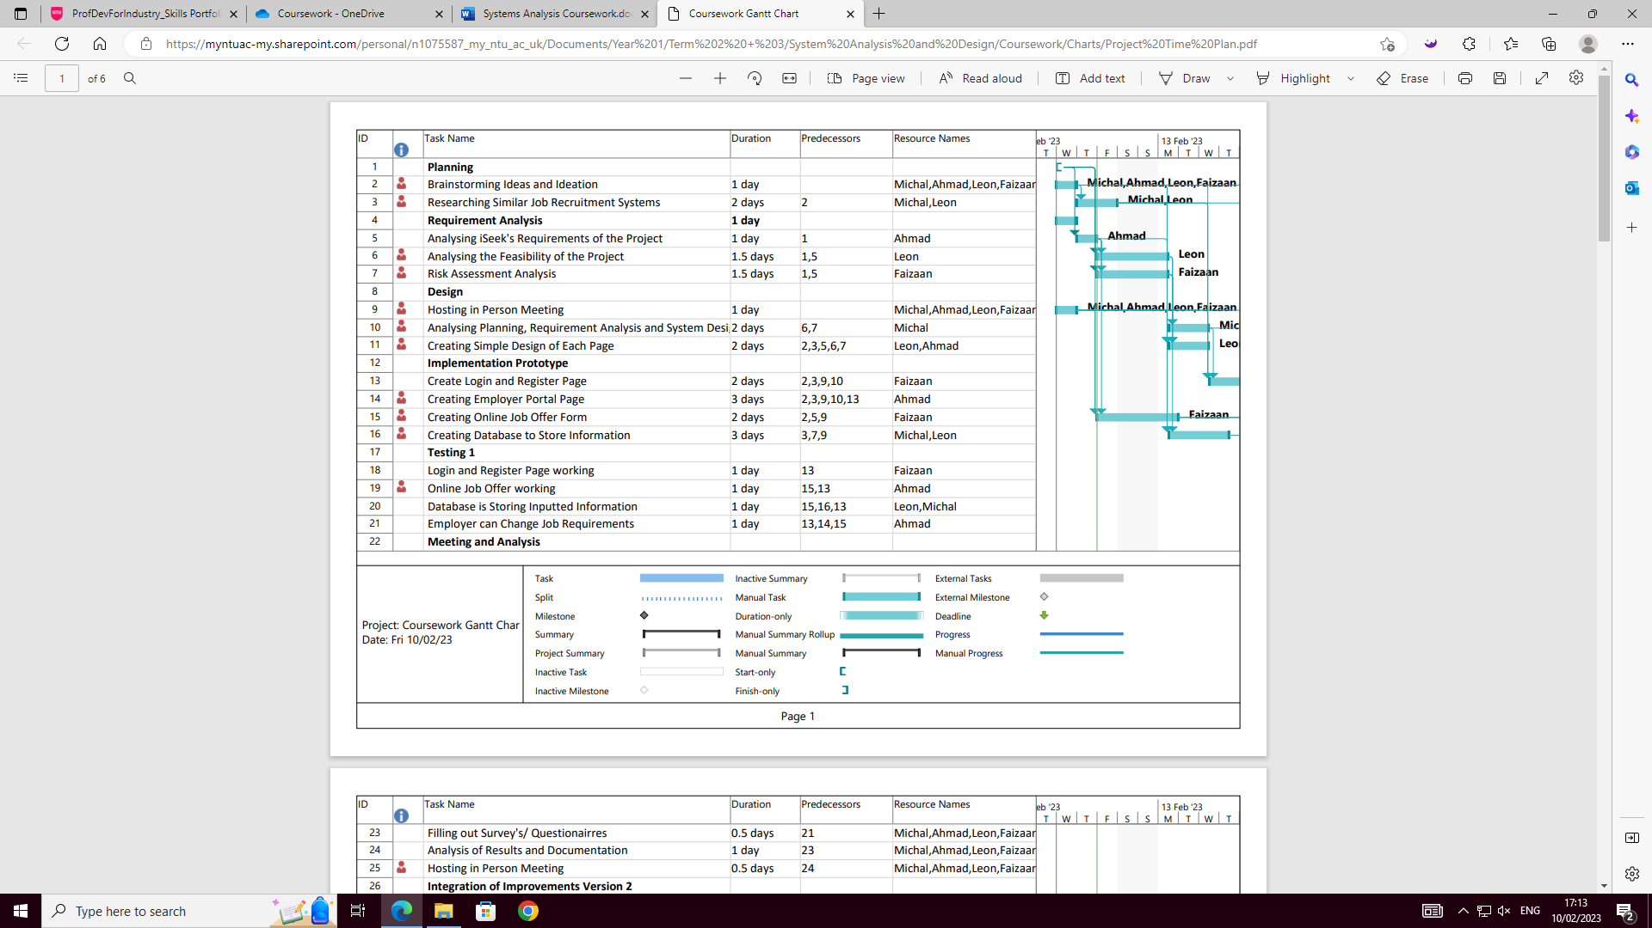

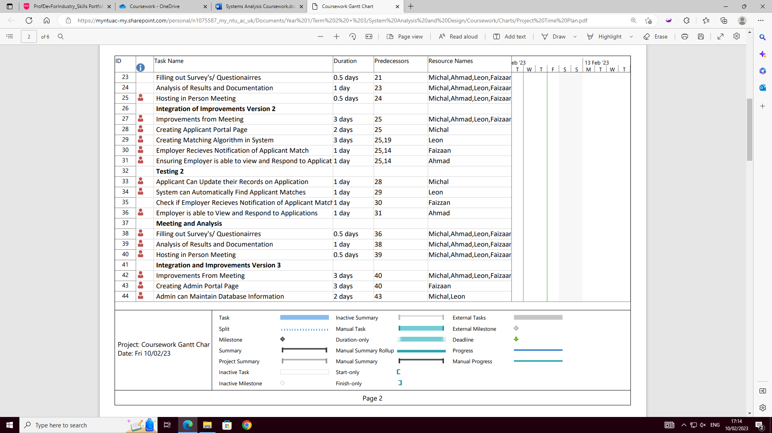

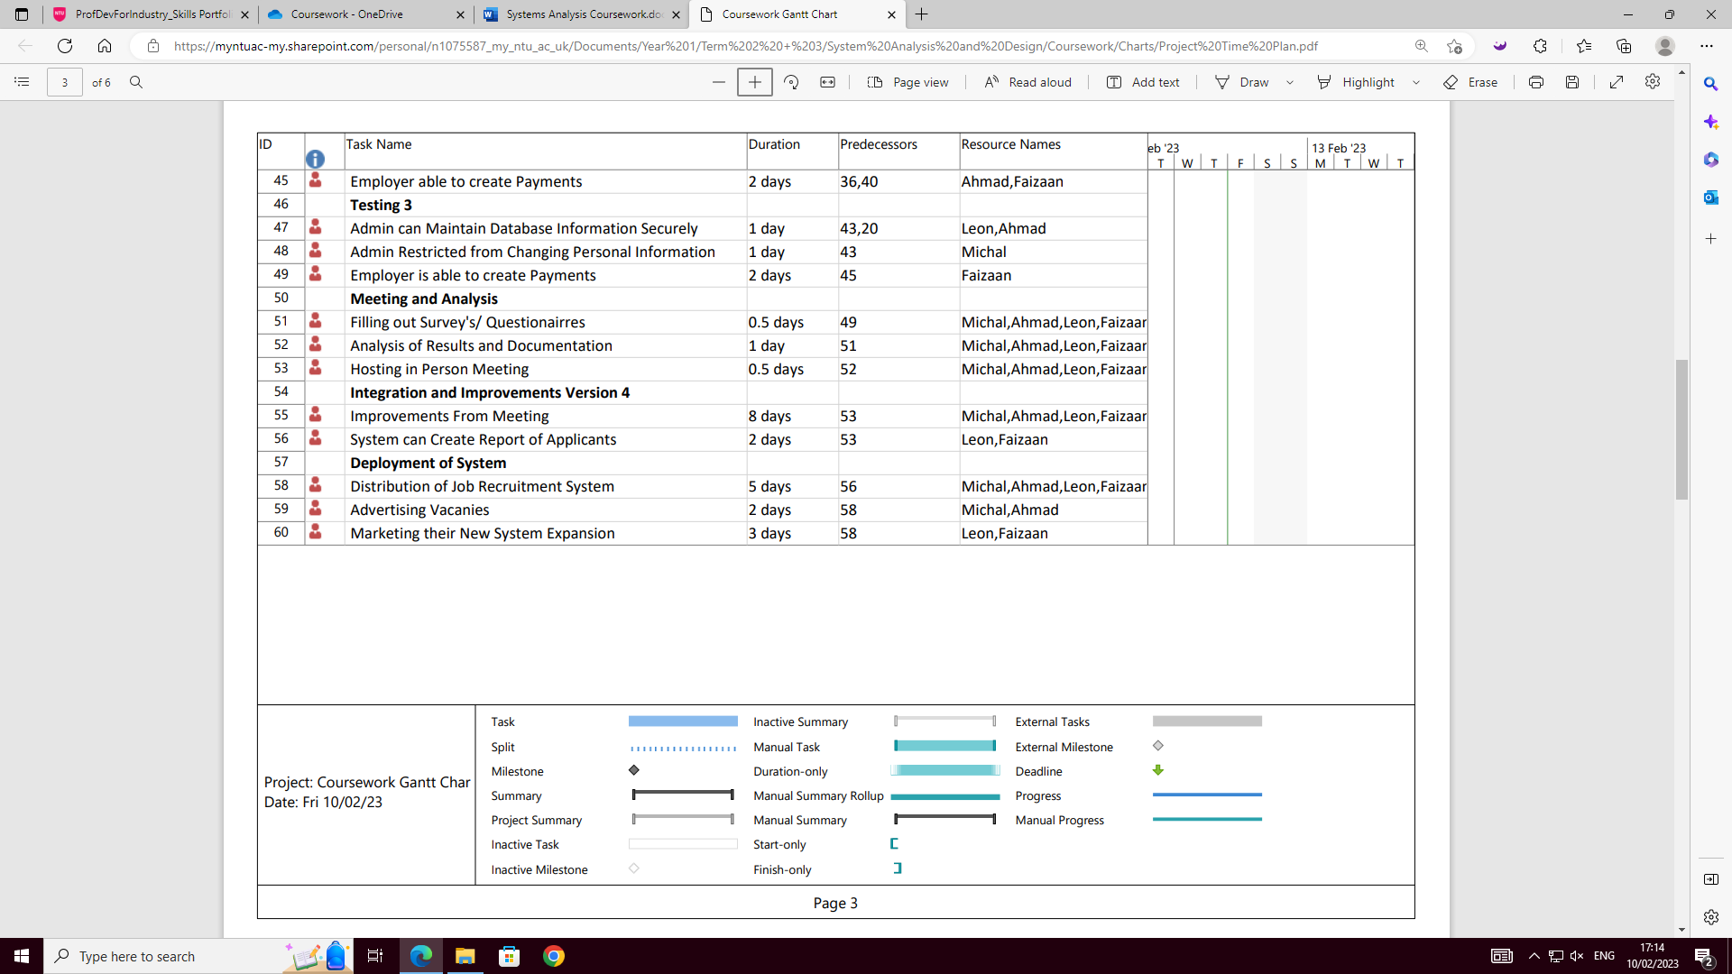

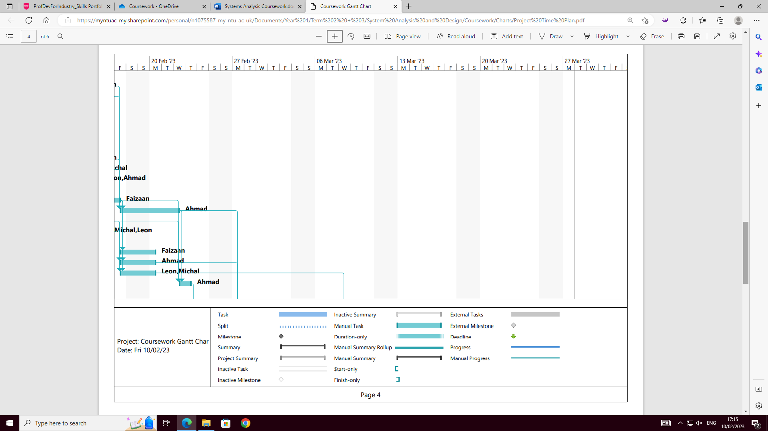

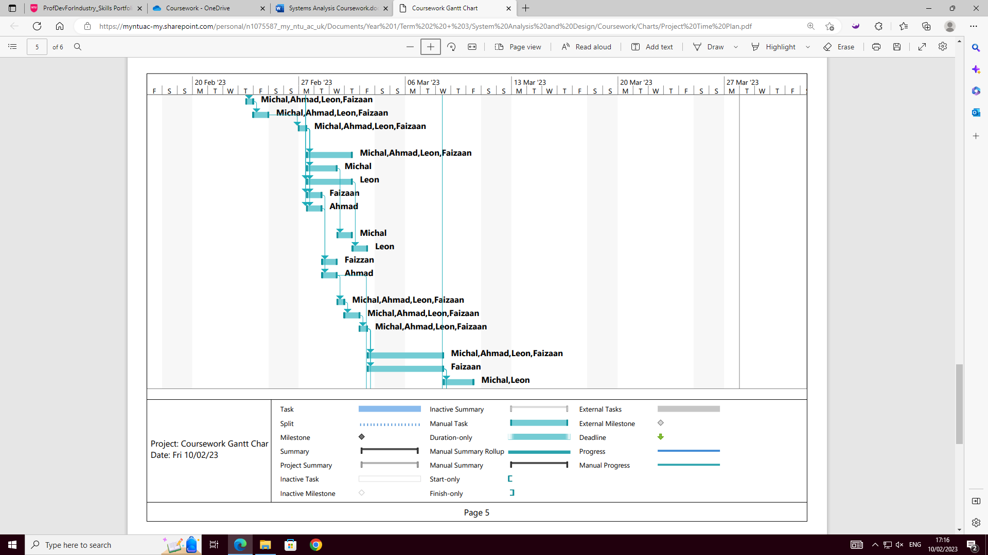

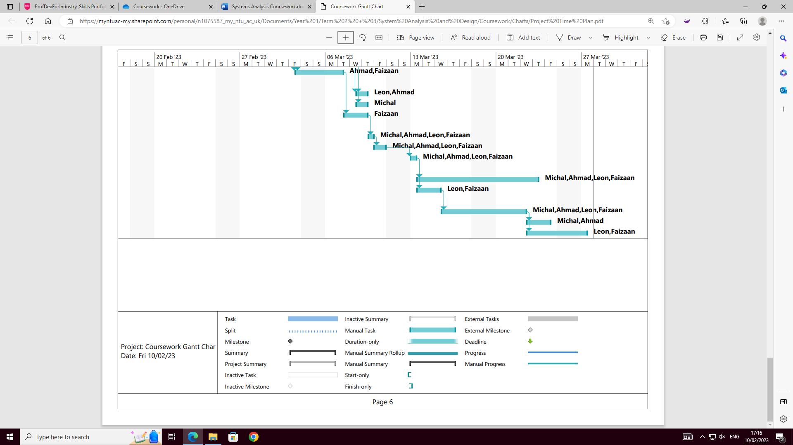

The Project Time Plan for the project has been created to effectively plan and develop the Job Recruitment System, step at a time. This would make sure that all the required activities are completed, and each key milestone is met. From our Project Time Plan we can see clear structure of the phased development methodology where the implementation phase is repeated 3 times to analyse and improve upon the previous version of the system. In each cycle of the phased development methodology, includes testing of new features, hosting an in-person meeting, analysing results of testing, and providing possible solutions and improvements. After this, the improvements from testing and the meeting would be implemented to improve upon the previous version before continuing the next phase and adding new features. This way, our development team would provide regular feedback so that the Job Recruitment System can as functional and best as possible, with all iSeek’s requirements met. The Project Time Plan is categorised in 4 main categories, the Planning, Analysis, Design, and Implementation phases with the Implementation being the longest development phase in the methodology.

All the main tasks have been clearly defined and would therefore be easy to manage progress in the development of the system. Activities and associated resources have been identified so that the time constraints can be met, and the system can be developed to a high standard and each member of the team had been appropriately allocated tasks to complete. To save time, some tasks can be completed at the same time. However, some key tasks such as the improvement of version after the meeting could only be completed after features have been developed and the team meeting had taken place before starting the next phase of the phased methodology. If the development goes according to schedule, the project should be successfully completed in 80 days/ 4 months.

When creating the Project Time Plan, some additional features of the tool allowed us to see how the diagram can be used to manage the project. The tool was able to create an Activity Network from the developed Project Time Plan to show the progression of the project and progression of tasks. The Activity Network allows us to easily document the implementation of system processes and features, so that the implementation phase of development can be documented. With the Activity Network will help us see if all the key milestones have been met and all iSeek’s requirements are met. This way, we can ensure that the product is fully functional and operational for the Applicant, Employer and Administrator to all use the Job Recruitment System. The Activity Network shows the relationships between activities and is therefore necessary for following the project critical path and quick path is the quickest. Using this diagram, we can predict the expected project time, so that it can be controlled and ensure that the Job Recruitment System can be developed in the 4-month timeframe.

**Requirements Analysis – Week 3**

**Requirement Capturing Method:**

Interview Transcript between the System Analyst and the Project Manager:

*System Analyst:* Good morning. Thank you for your time to meet with me today.

*Project Manager:* Good morning, it's my pleasure. What can I help you with today?

*System Analyst:* I wanted to discuss the Job Recruitment System project that we are working on. I wanted to gather some information about the goals and objectives for the project. Could you give me a brief overview of what we are trying to achieve with this project?

*Project Manager:* Our project is to develop a new Job Recruitment System and Management System for our company. The goal is to improve customer satisfaction by providing a more streamlined and efficient process for handling customer inquiries and complaints.

*System Analyst:* That sounds great. Could you tell me a bit more about the specific requirements we need to make sure the targets are met?

*Project Manager:* Of course. The system must be user-friendly and accessible to all employees and provide real-time reporting and analytics capabilities. Additionally, it must be scalable and flexible for future growth and should be delivered within the given budget and timeline.

*System Analyst:* Thanks for the information. Could you also tell me about the resources that will be available for the project, such as the team members and their roles?

*Project Manager:* Sure. We have a cross-functional team consisting of developers, testers, a system analyst and a UI designer. I will be serving as the project manager, and we will also have a project sponsor for the marketing side who will provide support and guidance as needed.

*System Analyst:* That sounds like a great team. When is the deadline for this project and how are you going to manage the time?

*Project Manager:* The project is expected to take approximately four months, with the goal of going live by the end of April this year.

*System Analyst*: Okay, thank you for the information. I think this will help me to develop a comprehensive plan for the project. Is there anything else you would like to add?

*Project Manager:* No, I think that covers it. If there is anything else you need, just let me know.

*System Analyst:* Thank you for your time. I appreciate your help in getting a better understanding of the project.

*Project Manager:* No problem. I'm always here to help. Let's work together to make this project a success.

**Requirement List:**

Employer’s Functions:

1. Register – The Employer should be able to register and create an Employer account by entering their username and password, so that they will be able to access the Employer’s Portal.
2. Login – The Employer should be able to login at any time into their Employer Portal using their username and password. They should also be able to change their password if they forgot it.
3. Manage Vacancies- The Employer should be able to manage vacancies and upload them onto their portal so that Applicants can apply for one of their vacancies.
4. Pay Administrative Fees – The Employer should be able to use the system to pay administrative fees should the Applicant get hired after the interview.
5. Manage Interview Invitation – The Employer should be able to view the Applicants information and invite them to an interview, if the Employer thinks that the person meets their requirements and needs.

Applicants Functions:

1. Register – The Applicant should be able to register and create an Applicant account by entering their username and password, so that they will be able to access the Applicant Portal.
2. Login – The Applicant should be able to login at any time into their Applicant Portal using their username and password. They should also be able to change their password if they forgot it.
3. Edit Registration Details – The Applicant should be able to edit their application details in their vacancy registration at any time.
4. Search and Apply for Vacancies – The Applicant should be able to browse through their Portal to search, find and apply for job vacancies.
5. Accept/ Reject Interview Requests – The Applicant should be able to accept or reject their interview request sent by the Employer.

Administrator Functions:

1. Manage Employers and Applicants – The Administrator should be able to manage Employers and Applicants information in the database so that all data is stored correctly and securely.
2. Manage Vacancies – The Administrator should be able to manage vacancies and upload them onto their portal so that Applicants can apply for one of their vacancies.
3. Manage Payments – The Administrator should be able to manage payments through their system securely.
4. Generate Reports – The Administrator should be able to create reports about the functionality of their system and the areas in which features could potentially be improved.

|  |  |
| --- | --- |
| **Functional Requirements** | **Description** |
| Register | Process-Oriented Requirement:   * The Applicant, Employer and Administrator should all be able to register and create their account by entering their username and password, so that they will be able to access their Portal that gives them their privileges. * The system must perform, for the system to meet the requirements. |
| Login | Process-Oriented Requirement:   * The Applicant, Employer and Administrator should be able to login at any time into their Portal using their username and password. They should also be able to change their password if they forgot it. * The system must perform, for the system to meet the requirements. |
| Manage Vacancies | Process-Oriented Requirement:   * Both the Employer and Administrator should be able to manage vacancies and upload them onto their portal so that Applicants can apply for one of their vacancies. * The system must perform, for the system to meet the requirements. |
| Pay Administrative Fees | Process-Oriented Requirement:   * The Employer should be able to view the Applicants information and invite them to an interview, if the Employer thinks that the person meets their requirements and needs. * The system must perform, for the system to meet the requirements. |
| Search and Apply for Vacancies | Information-Oriented Requirement:   * The Applicant should be able to browse through their Portal to search, find and apply for job vacancies. * The system must contain information. This ensures that the Applicant can find the open vacancies and its requirements so that they can apply for them. |

|  |  |
| --- | --- |
| **Non-Functional Requirements** | **Description** |
| Pay Administrative Fees and Manage Payments Securely | Operational, Performance and Security Non-Functional Requirements:   * The Administrator should be able to manage payments through their system securely and the Employer should be able to use the system to pay administrative fees should the Applicant get hired after the interview. * Since this process is very important to ensure that no financial information is stolen, it must be secure. * They require to pay these administration fees through their system, while also being reliable and secure. * This is needed to make sure that the system does not breach the GDPR laws. |
| Manage/ Accept and Reject Interview Invitation | Operational and Performance Non-Functional Requirement:   * The Employer should be able to view the Applicants information and invite them to an interview, if the Employer thinks that the person meets their requirements and needs. * The Applicant should also be able to accept or reject their interview request sent by the Employer. However, this can also be done automatically by the system matching algorithm, so the Employer doesn’t have to manually check each application. * This allows for better communication and reduces the room for error. |
| Edit Registration Details | Performance Non-Functional Requirement:   * The Applicant should be able to edit their application details in their vacancy registration at any time. * The system doesn’t need the Applicant to change their application details once they are sent, however it would improve functionality and performance if they would be able to update their application even after it had been sent. |
| Generate Reports | Security and Operational Non-functional Requirement:   * The Administrator should be able to create reports about the functionality of their system and the areas in which features could potentially be improved. * It would allow the Administrator to manage and see if the system is functional and operational in practice and what can be done to improve the experience. * This would also help their business operate as they would be able to manage their information and spreadsheets more quickly and securely, rather than on paper. |

**Functional Analysis – Week 4**

**Use Case Diagram:**

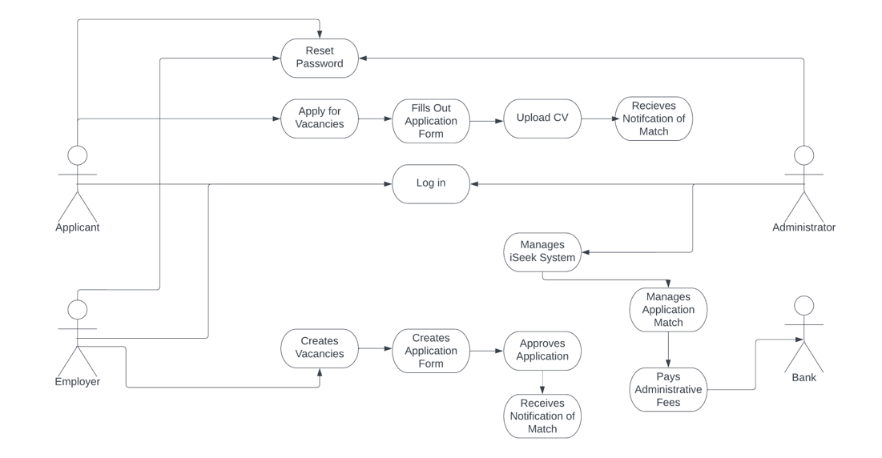

The Use Case Diagram provides an overview of the main functions of a recruitment system and how different actors interact with the system. The clients will go into the system to make an account that they can log in and reset the password of their accounts to apply for jobs and upload their CVs into the application. The employer will create the job applications to make the clients apply into their suitable vacancies. The clients and administrator will be able to make accounts to log in into the systems. However, the administrator can manage the matching of the system and can pay the administrator fees. When paying administrator fees, the administrator is in contact with the bank. The Applicant, Employer and Administrator can all log into the system but due to access rights, they all have different functions that they can perform to improve functionality of the Job Recruitment System.

**Structural Analysis – Week 5**

**Class Diagram:**

A single Administrator and simple Employer can login into the Login Portal Page of the Job Recruitment System using their username and password. Multiple Applicants can log into the Login Portal Page of the Job Recruitment System. Each of them can use the same portal to access their Employer/ Administrator and Applicant accounts by entering their username and passwords on the login page. On this page they are also able to change their password just in case they forgot their password and would still be able to access their account.

After logging in, the Employer, Administrator and Applicant should be able to view their Personal Details such as their Name/ Surname, address, phone number, email, date of birth alongside their Employer ID/ Admin ID or Applicant ID. From their account, the Employer would be able to create and edit their new Job Offer and offer matching Applicants interviews. The Administrator should be able to approve these matches through their account and the Applicant, through their account, should be able to fill out and later modify their application form and should be able to accept or reject interview requests from the Employer. Both the Employer and Applicant receive a notification if a match is found by the system and approved by the Administrator so that the Employer can proceed with the application process and the interview request.

The Employer, after accessing their account can create an application form on their system that includes information like the Vacancy name and information, the application title, personal details, including work experience, qualifications of the Applicant. Through their application they should also be able to upload their CV. The Applicant should be able to access the application form from their account and should be able to fill out all the details, while also being able to save, edit and submit their application to the Employer. After the application form is filled out, the system automatically finds matches for the job. This matching system can be managed by the administrator through their account to help in the future, if the matching system is faulty so that no productivity is lost, and matches can be approved. After a match is found and approved, then a notification is sent to the Applicant and the Employer with information about match and their application form. The Applicant, from their account can accept or reject the interview invite with the Employer. Should the Applicant be hired, a payment is sent to the bank to pay administrative fees.

**UML Class Diagram:**

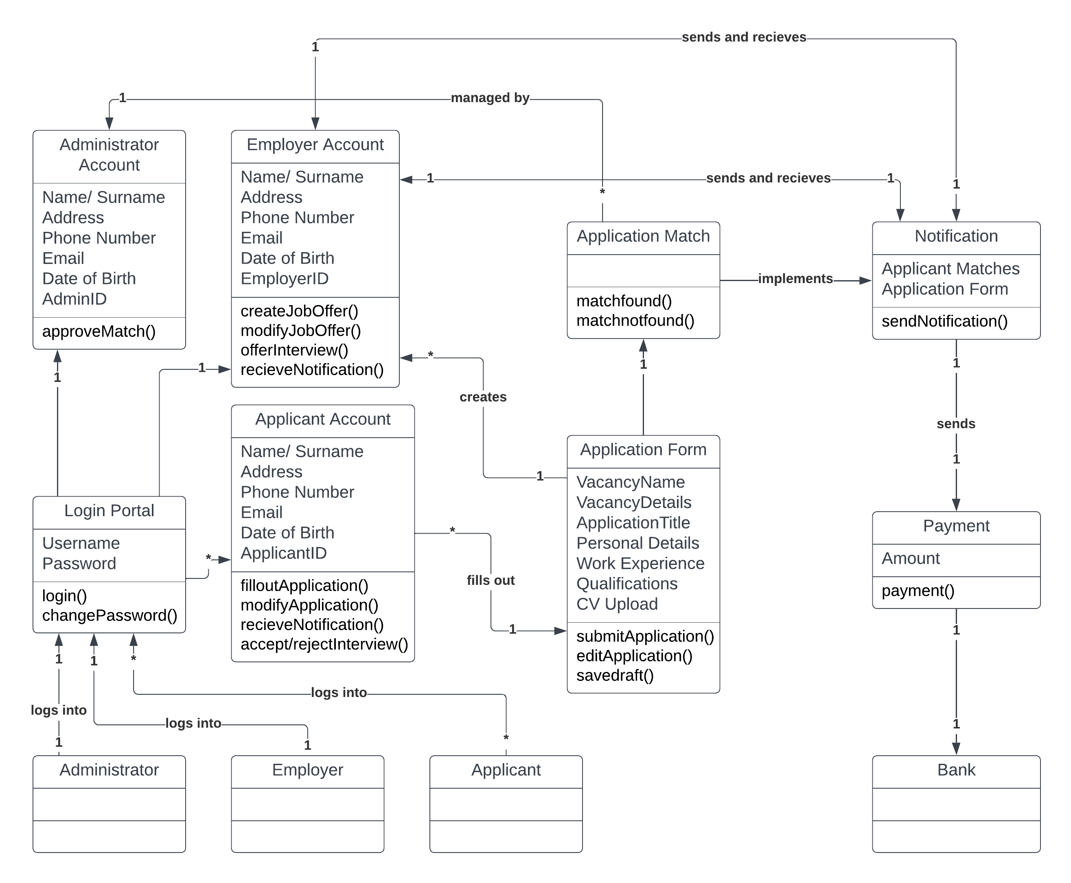

**Database Design – Week 6**

**ERD Diagram:**

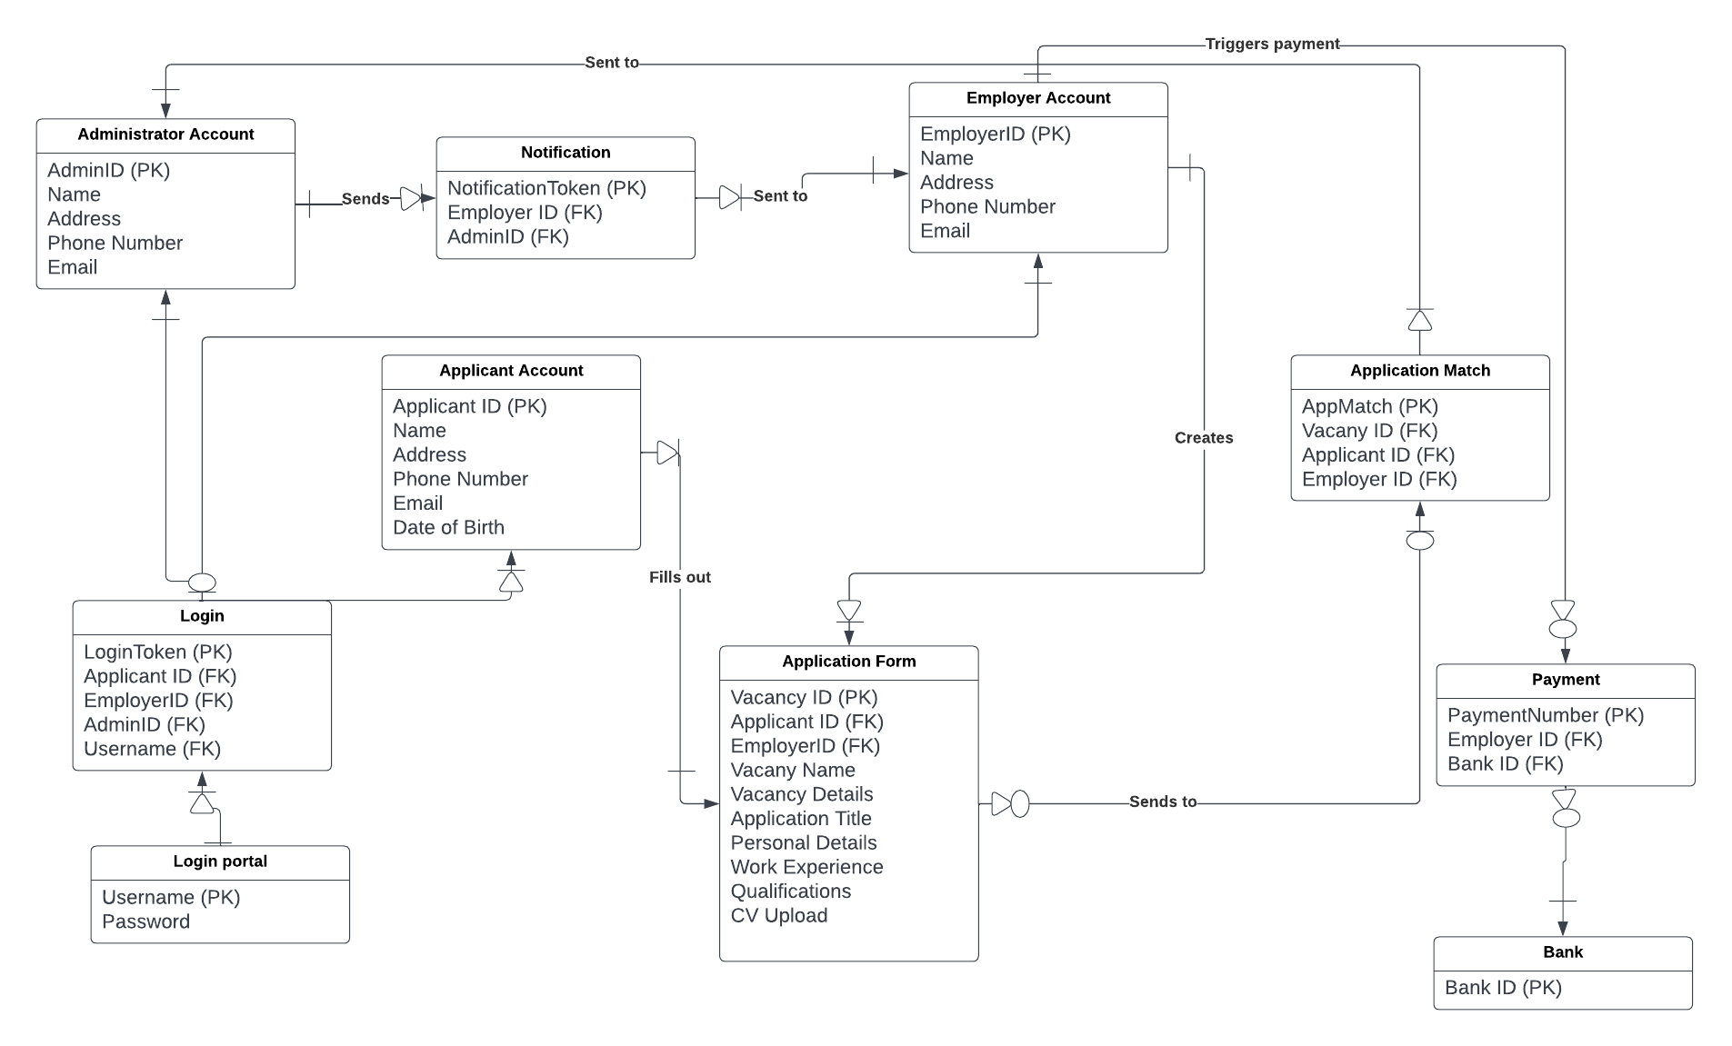

This entity relationship diagram shows the different relationships each class has and their associated attributes. This is based on what we did in the previous diagram however mapped out using a separate technique. There have been relational classes created to provide a link between areas which previously had the many to many or 1 to 1 and have been sorted as such, for example Login was introduced to provide a link between the portal and each individual area. Each item on the diagram has its primary key which might be associated on something it is linked with or it has a foreign key showing that another item of a class has been linked with it. For example, in Bank, the primary key is employed as a Foreign Key under payment.

**Sample SQL:**

The SQL Select Statements have been created using the ERD Diagram that is able to complete the basic tasks of the Job Recruitment System such as the Applicant’s view. The first select statement allows the jobseeker to receive a notification, when a match has been found in their application by the system. The only condition on whether they receive a notification is that the Applicant has more than 2 years of experience. For the second Select statement, a script has been created for the jobseeker that they only receive a notification from the system if they have more than 2 years of experience and have a bachelor’s degree. The system will find a match from the Applicant’s application form and process their work experience and qualifications for the system to send the Applicant an automatic interview.

SELECT

,[AppMatch (PK)]

,[Notification Token (PK)]

FROM [Application Match]. [Notification].

SELECT

,[Work Experience] (2 years+)

,[Qualifications] (Bachelors)

FROM [Application Form].

**User Interface (UI) Design – Week 7**

**UI Prototype:**

**Employer View:**

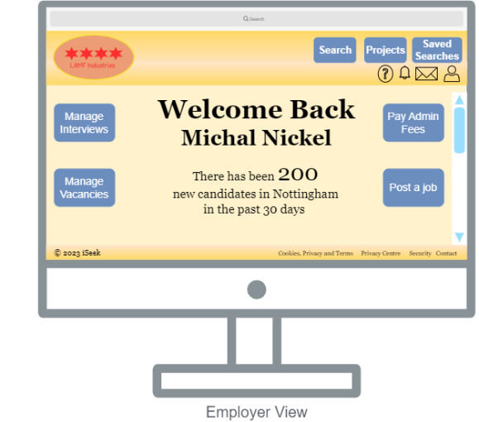

This is the Employer view of the Job Recruitment System. Since the Employer would most likely be using a desktop computer in the professional workplace and in their business, the Prototype UI design would be developed to work on desktop devices with a large screen size. Some potential improvements in the future could include adjusting the layout of the system to support mobile phones, however the greatest number of users would be applying for a vacancy on a computer device. The top of the screen includes a search bar, as you would find on any web browser, with a large navigational bar on underneath. In the top left of the navigational bar there would be the company logo of iSeek (the LAMF Industries logo is there as a placeholder). The navigational bar has a few key buttons on the top right of the screen which include the search, projects and saved searches button. Their function is the allow the Employer to quickly and efficiently access and search for Applicants in the nearby area and can have them all saved in a Saved Searches menu. Underneath the large buttons we have 4 small icons that represent the account, messages, notifications and a help icon. These will all create a dropdown menu when the icon is clicked on to have the Employer specify the options they want to access. With this the Employer would quicky and efficiently be able to view messages and reply to them without having to search through the menus.

In the centre of the screen there is a large “Welcome Back” and displays the Employer’s First and Last Name as a quick welcome message as soon as they log into their portal. There are 2 buttons on both sides of the screen which are the main functions the Employer that relocates them to an external page where they can post a job vacancy, manage those vacancies, manage their interview requests after matches are found by the system, after which they can pay their admin fees. In the centre of the screen there is also a message showing how many applicants have been looking for new jobs in the area to help the Employer see the number of people looking for jobs in the past 30 days. At the bottom of the screen, we have a small bar with the copyright trademark of iSeek 2023 on the left. On the right side, we have the cookies, privacy and terms of service, privacy centre, security and contact information about iSeek.

**Applicant View:**

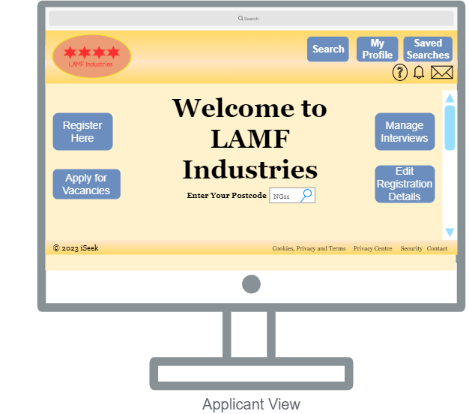

This is what the applicant will see as he/she goes into the main page of the company’s website. First the button at the top is for searching for jobs, employers' names, and any information about the company. The second button is to view the profile that registered in the company’s system. The third button is for any jobs that the applicant saved to view later. The buttons at the middle of the main page, the first one in the left is for register a new account if the applicant have not already done so. The second button is for applying for jobs once the applicant clicks on it, vacancies that are available will appear to the applicant. The first button on the right is for accepting or refusing interviews if the candidate has been invited for an interview. The second button is for editing the information of the applicant on his/her profile. The search bar in the middle is for searching for jobs that available in a nearby area it depends on where the applicant entered the postcode.

**Administrator View:**

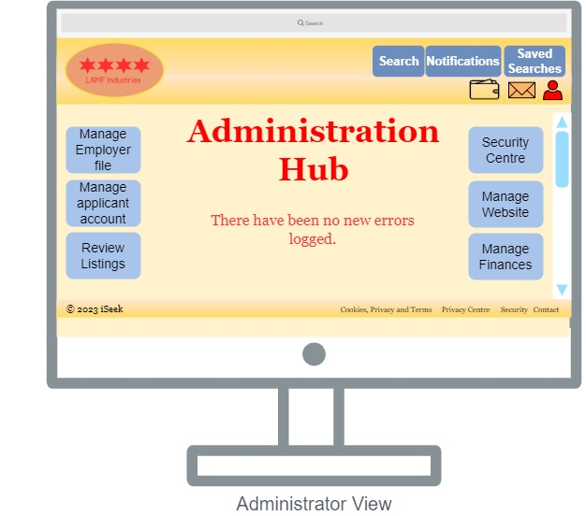

This is our idea of what the Administration view would look like for our website. The first point to note is that the overall layout and style is mostly consistent with that of the Employer and Applicant view looks like. This was done to keep consistency with the way the website is designed so it will be easier for users to operate without using any functionality. Some key points to note for this view is that in the middle it is in large red text stating that this is the administration hub and not a personal account. This also presents the idea that there could be multiple administrators accessing one hub. On the top contains our company logo and the same search and saved searches bar to make it easier for the administrator to navigate. In the middle replacing where the profile would be for the other views is the notification tab to give the administrator access to all notifications sent to them regarding the website on action to take. Just below that we have three buttons. The person shaped figure further highlighted in red to emphasise that this is the admin view, allows the administrator to create new accounts manually or manage their own. Next to it we have the mail icon to take the administrator to a page where any mail regarding queries or issues users have sit. Next to it we have the financial area where the administrator can manage finances as required.

Going down on the right-hand side of the page we have the Security centre, manage website, and manage finances buttons. The manage finances button also links to the same areas the icon does for easier access. The security centre allows the admin access to the website's security software and any outstanding issues that need to be resolved can be rectified on that area. Next, we have the manage website which allows the administrator to perform most functions on the website from changing anything to fixing the layout. On the left-hand side, we have the admin's ability to manage and reset passwords for either the employer or applicant account on two separate areas to prevent confusion. There is also a review listings area where the administrator can review all job listings and take listings down as required.

**References:**

David Battson, 2014. Top 10 considerations when choosing a Database Management system. DataHQ, Chelmsford, Essex.

Everett, G.D., McLeod, R., 2006. The Software Development Life Cycle. In: Software Testing. Hoboken, NJ, USA: John Wiley & Sons, 2006, pp. 29–58. 10.1002/9780470146354.ch2.

**Appendix:**

**Meeting Evidence:**

